

**CSIT314 Meeting Minutes 1**

| **Date:** 9 April 2022 | **Time:** 11.30PM-1.30AM | **Venue:** Zoom |
| --- | --- | --- |
| **Attendance** | | |
| **Name** | **Student Number** | **Present/Not Present** |
| Chong Hui Wen | 7311436 | Present |
| Lee Yu Xian | 7233164 | Present |
| Kaycee Tan Wan Ching | 7311540 | Present |
| Li Jin | 6650181 | Present |
| Kendrick Kee | 7366814 | Present |
| Bryan Choo | 7060452 | Present |
| Soh Wei Liang | 7083294 | Present |

**Agenda:**

The Team will decide on the:

* B.C.E (Boundary, Control, Entity) of this project
* The types of Users that will interact with the product
* The types of User data that needs to be collected (database)
* List of complete tasks for each user story (requirements)
  + First draft by 16th April 2022
* Timeline for various stages in the project (Gantt Chart)
  + Developing use case diagrams and descriptions
  + Sequence diagrams
  + Class diagram
  + UI Design and implementation
  + Final Report
* Discuss possible ethical considerations in developing the software system in this project and how to address them
* Style guide of our application (Color palette, logo etc)

The team will setup Taiga and decide:

* CI/CD pipeline
* Whether to integrate Taiga with GitHub

**Progress Report:**

**Discussion Summaries:**

Roles Decided:

1. Scrum Master = Kendrick Kee
2. Solutions Architect = Chong Hui Wen, Li Jin
3. Back End Developer = Soh Wei Liang
4. Front End Developer = Kaycee Tan Wan Ching
5. Devops Developer = Lee Yu Xian
6. Quality Assurance Engineer = Choo Xu Guang Bryan

Agile Methodologies:

* Decided to use Scrum

Software Development Methodology:

* Decided to use B-C-E Framework

Devops Pipeline:

* To research what are the available options and decide

Database Storage

* Users
  + Admin
  + Guest
  + Member
* Orders
  + Table #
  + User
  + Item
  + Status
* Menu Items
  + Food Picture URL
  + Price
  + Name of item
  + Quantity
* Cart
* Promotions
  + Name
  + Promotion Period
  + Promocode
  + Value of promo (%)

Use Case:

1. Super User (Developer)
   1. Access to all functionalities
2. Customer (Guest/Member)
   1. Guest
      1. View Menu
      2. Add Food Item to Cart
      3. Quantity
      4. Remarks
      5. View Cart
      6. Edit Cart
      7. Delete Food Item from Cart
      8. Make Payment
      9. Sign up as Member
   2. Member
      1. Login as member
      2. View Menu
      3. Add Food Item to Cart
      4. Quantity
      5. Remarks
      6. View Cart
      7. Edit Cart
      8. Delete Food Item from Cart
      9. Make Payment
3. Restaurant Manager
   1. Has access to functionalities on top of a Restaurant Staff
   2. Add Food Item
   3. Remove Food Item
   4. Edit Price of Food Item
   5. Insert Coupon Codes
   6. Insert promotional food items
   7. Highlight popular food items
4. Restaurant Staff
   1. Login as staff
   2. Verify order has been delivered (Mark as table has received the food item)
5. Restaurant Owner
   1. Statistics such as Average spending per visit
      1. Most popular food item
      2. Frequency of visits
      3. Last visit
      4. Preference for dishes/drinks

Design decisions:

1. Color Palette: <https://coolors.co/palette/000000-14213d-fca311-e5e5e5-ffffff>

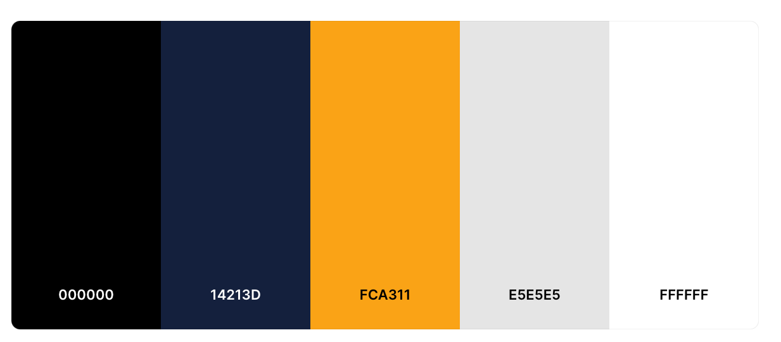

**Agenda for next meeting​​**

1. Decide on functional/non-functional requirements
2. Timeline for various stages in the project (Gantt Chart)
3. 1st draft for Use Case diagram and description (for all users)
4. 1st draft for Class/Sequence Diagram/Gantt Chart
5. Login Page for customer
6. Decide on Technology Stack
   1. PHP/ MYSQL ?
   2. Flask ?

**Recorded by: Kendrick Kee Date: 9 April 2022**

**Vetted by: Chong Hui Wen Date: 9 April 2022**